2nd International Forum on Frontiers of Automation and Artificial Intelligence (FAAI 2020, http://conf.kzgc.com.cn/iai2020/), which will be held on October 22-23, 2020, in Shenyang, China, as a part of the 2nd International Composite Conference on Automation and Artificial Intelligence (ICCAAI 2020).

Distinguished Lecture (1 hour)

**Title:**

Smart Control Engineering (SCE), Digital Twins, and Industrial AI (IAI) – A New Frontier

**Abstract:**

Experienced control engineers and researchers agree that before we design a controller we need to ask two questions 1) “What do we have/know?” and 2) “What do we want?” and after we have designed a controller, we also need to ask two questions 1) “How optimal?” and 2) “How robust?” Now, with the emerging wave of “Digital Transformation” such as Industry 4.0, I promote to ask the third question: “How smart?” This talk suggests a new frontier for control engineering: SCE - Smart Control Engineering and I will show that digital twins (DT) are the enabler towards SCE, a consequence of IAI (industrial artificial intelligence). By “smartness”, following the notion of US NSF program on S&AS (smart and autonomous systems), we signify the following 5 attributes 1) Taskable; 2) Cognitive; 3) Reflective; 4) Ethical; 5) Knowledge-rich. In this talk, we will show a case study to illustrate the SCE enabled by DT using IAI.

**Speaker Biography:**

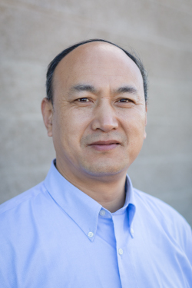

**YangQuan Chen** earned his Ph.D. from Nanyang Technological University, Singapore, in 1998. He had been a faculty of Electrical Engineering at Utah State University (USU) from 2000-12. He joined the School of Engineering, University of California, Merced (UCM) in summer 2012 teaching “Mechatronics”, “Engineering Service Learning” and “Unmanned Aerial Systems” for undergraduates; “Fractional Order Mechanics”, “Linear Multivariable Control”, “Nonlinear Controls” and “Advanced Controls: Optimality and Robustness” for graduates. His research interests include mechatronics for sustainability, cognitive process control (smart control engineering enabled by digital twins), small multi-UAV based cooperative multi-spectral “personal remote sensing”, applied fractional calculus in controls, modeling and complex signal processing; distributed measurement and control of distributed parameter systems with mobile actuator and sensor networks. He received Research of the Year awards from USU (2012) and UCM (2020). He was listed in Highly Cited Researchers by Clarivate Analytics in 2018 and 2019. His lab website is <http://mechatronics.ucmerced.edu/> and his publication list is at <https://scholar.google.com/citations?user=RDEIRbcAAAAJ&hl=en> (Email: [ychen53@ucmerced.edu](mailto:ychen53@ucmerced.edu))