Tour Agenda

Hour 1: CAD & 3D Printing

CAD: SolidWorks
Students will work in teams to utilize SolidWorks software on MESA Lab computers to create a simple LEGO block. Students will be provided a guide to follow, allowing them to easily create the project.
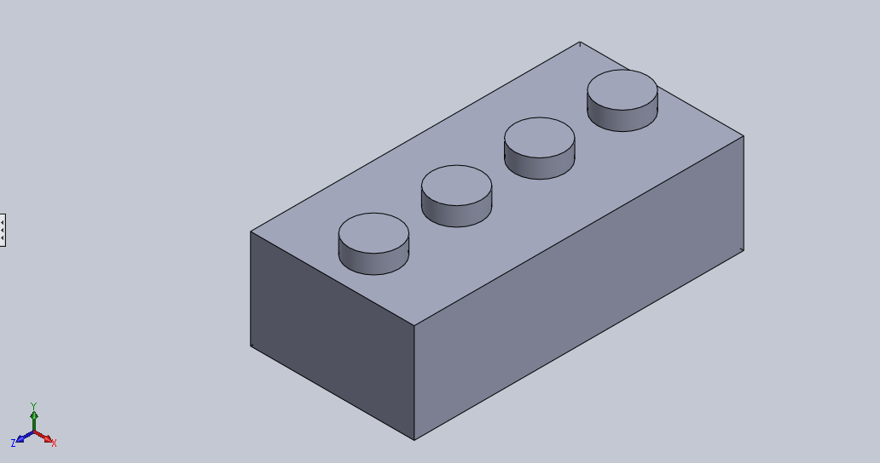

3D Printing
Students will be shown how to print their LEGO Blocks using the MakerBot 3D printing software. Once printable objects are created, teams will be able to print their projects on MakerBot 3D printers in the lab to take home at the end of the tour.

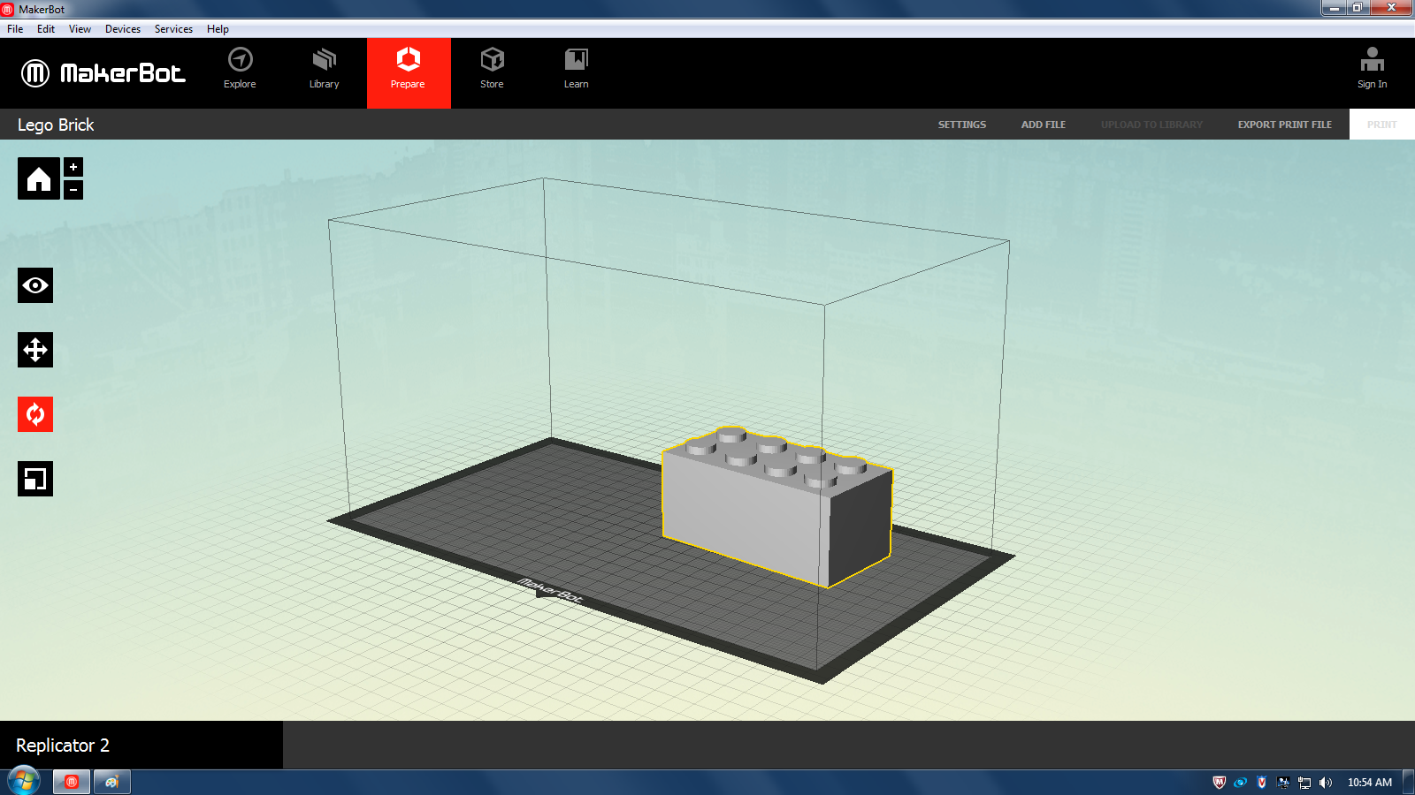

Hour 2: Arudino

Arduino
Students will build Arudino circuits using custom guides that are fitted to their learning level. During experiments, students should understand what they should learn from the circuits, what they should expect to see, and how experiments relate to real world situations.

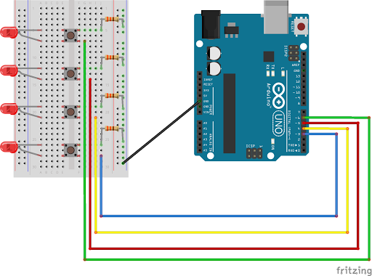

Hour 3: Drones & Questions
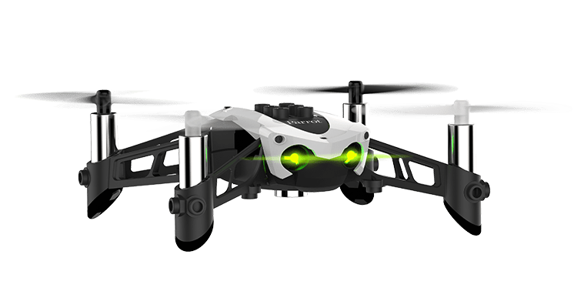

Drones
Students will have the opportunity to fly Parrot Mambo drones, and ask a licensed drone pilot questions. Students will also have the opportunity to practice their programming skills and program the mambo drones for simple autonomous flight paths.

Questions & Closing

The final time at the lab will be dedicated to answering student questions along with allowing teams to pick up their printed parts. Students will be able to walk around the lab, talk to lab members, and ask questions about their interests in the MESA Lab.

